Project 3

(1). Identify actors and use cases for the system described above and show them on a UML Use Case Diagram.

①AI建议的初始方案：

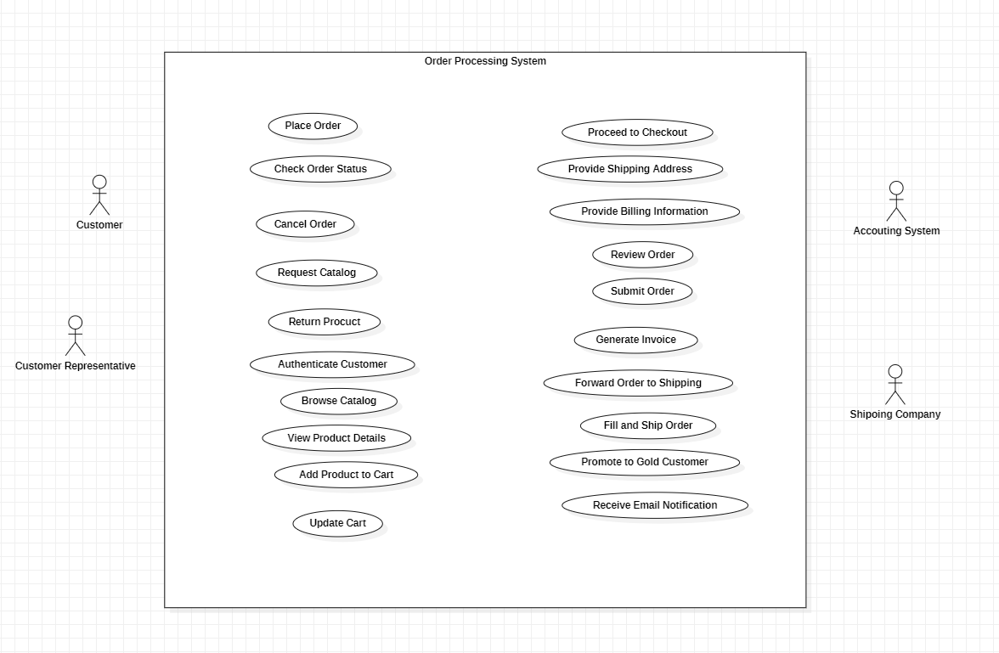

②优化后的最终方案：

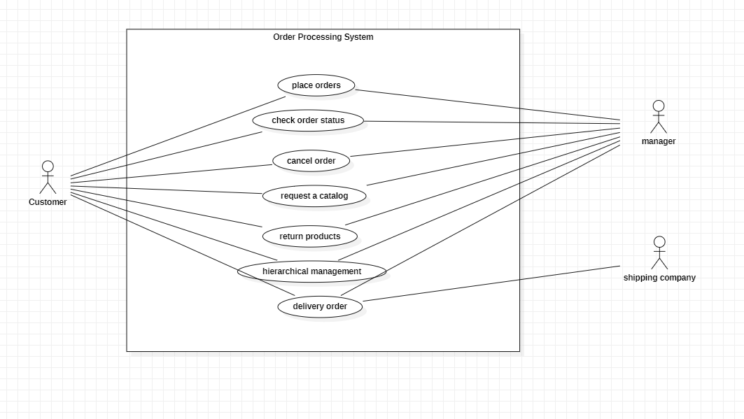

③区别：AI提供的方案有多个用例，不能够精简地表示内容，同时也没有提供各个用例与参与者之间、用例与用例之间的关系。

④过程记录：用时30秒

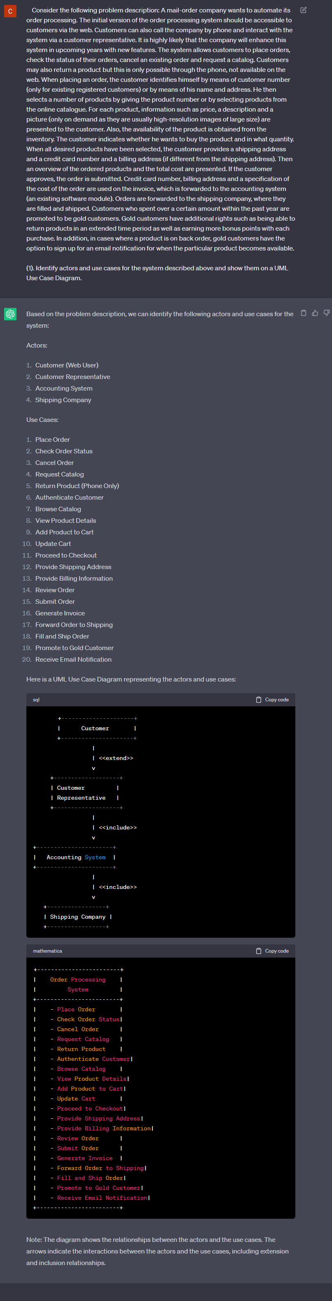

(2) Perform a quick application domain analysis to come up with an object model for the above system. Express your findings with a UML Class Diagram, making sure to identify any critical operations of classes.

Consider the following use case scenario (for use case “place order”):

*Ali is an existing customer of the order processing company described earlier, registered with their web site. Also assume that having browsed the printed catalogue he has, he already identified the two items (including their prices) he likes to buy from the company’s website using their product numbers (i.e. #2 and #9). First, he tries to buy one of product #2, but it is listed as unavailable in the inventory. Then, he adds two quantities of product #9, which turns out to be available, to his basket. He is then asked to confirm his registered shipping and billing addresses and credit card information from the customer database. He completes the order by clicking the Submit button. You may ignore processing of customer authentication.*

①AI建议的初始方案:

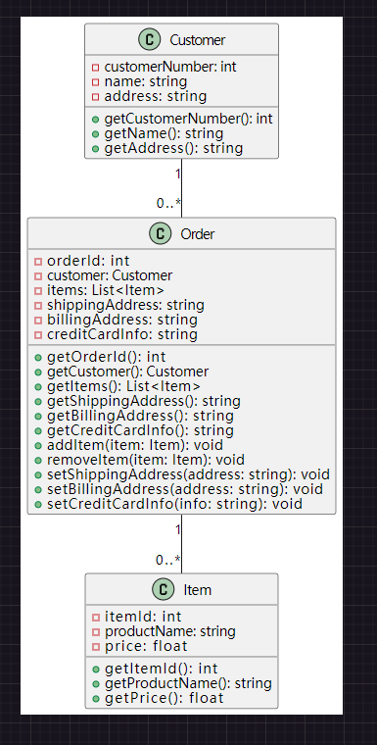

②优化后的最终方案:

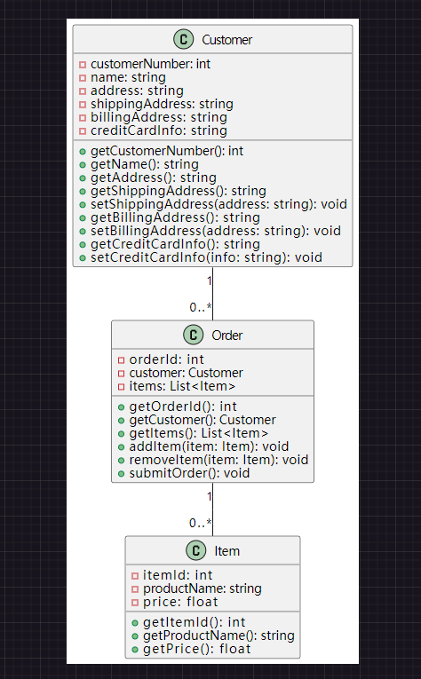

③区别：将registered shipping, billing addresses, credit card information归入user 类

④过程记录：用时17分钟

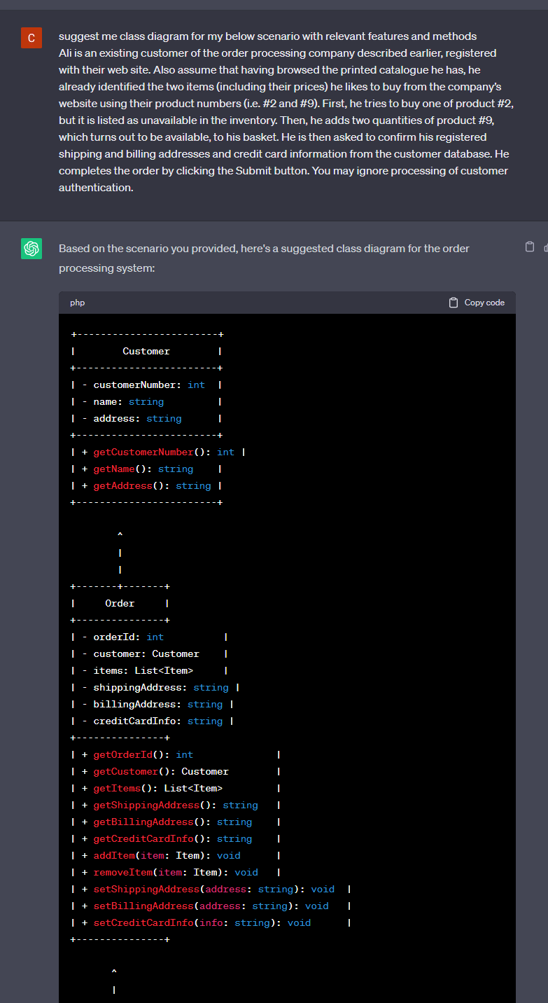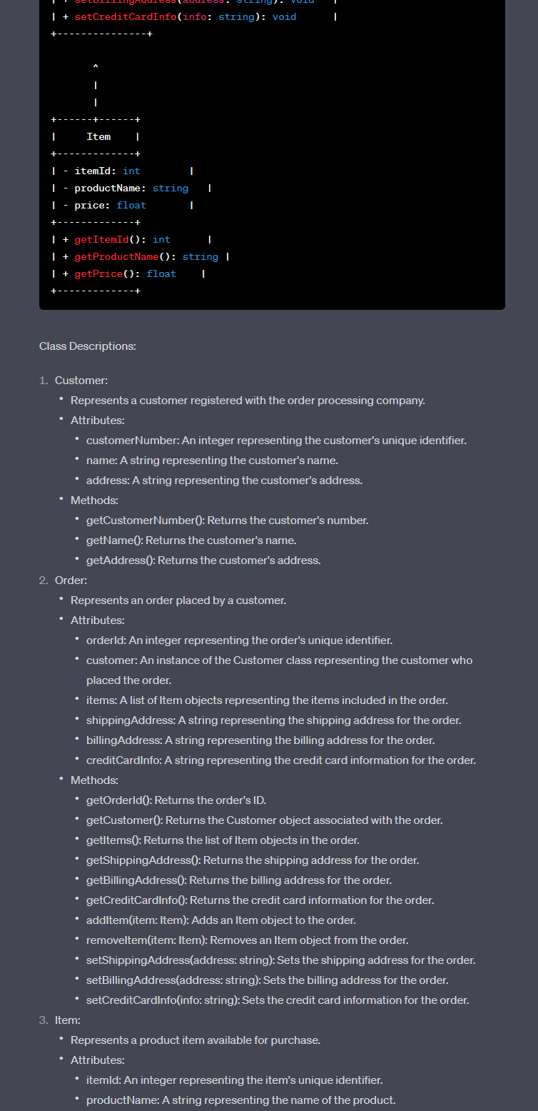

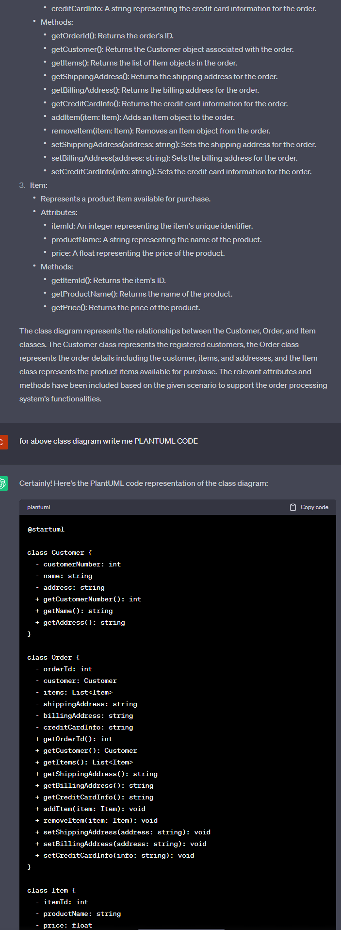

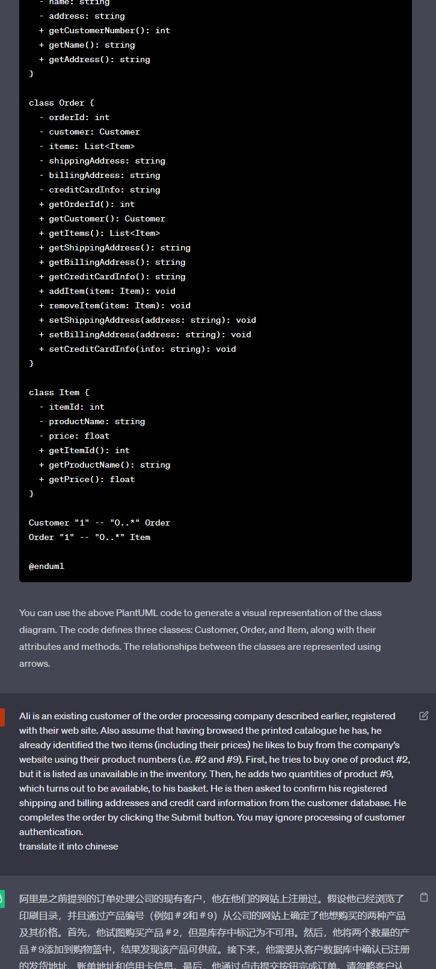

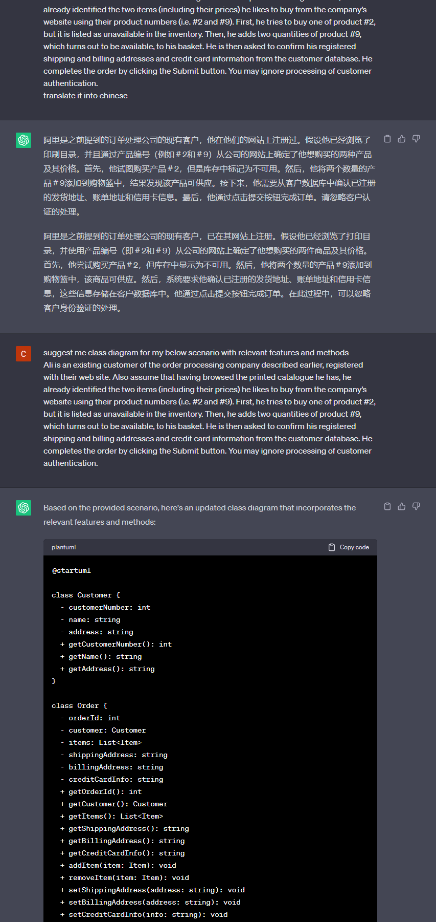

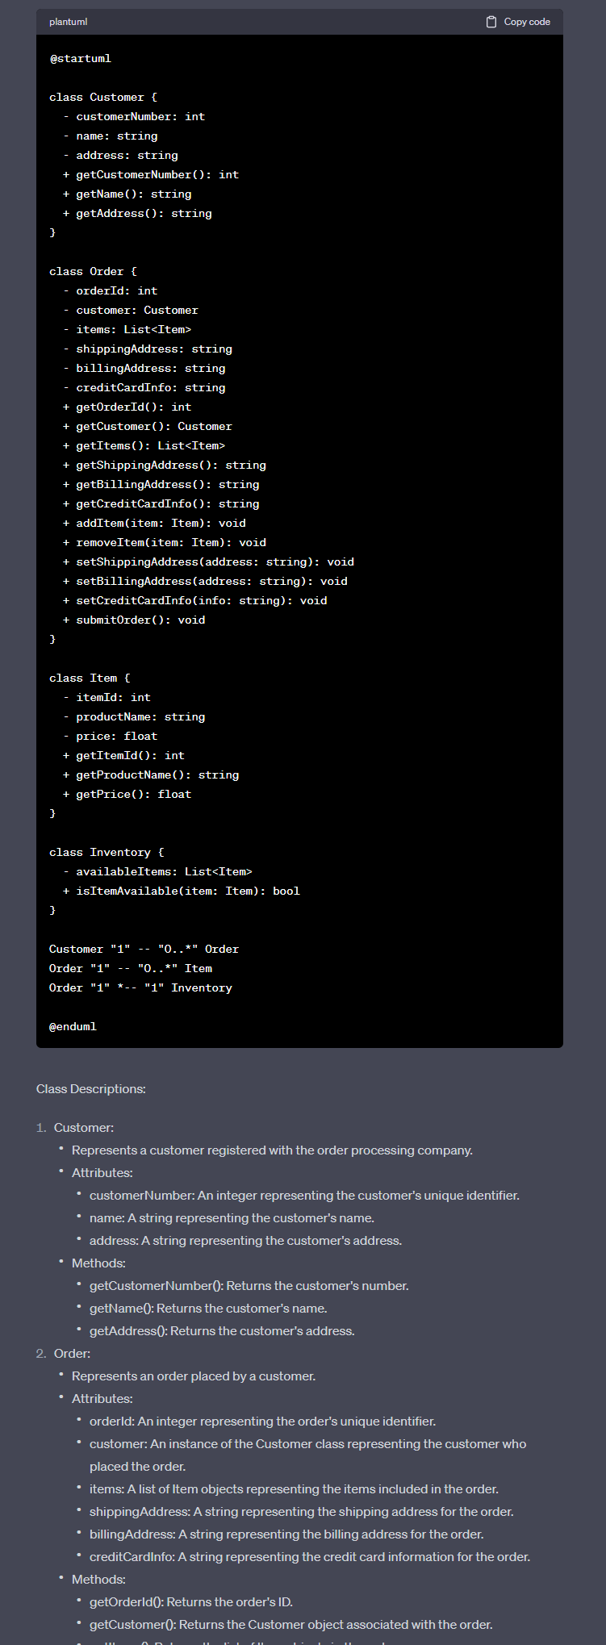

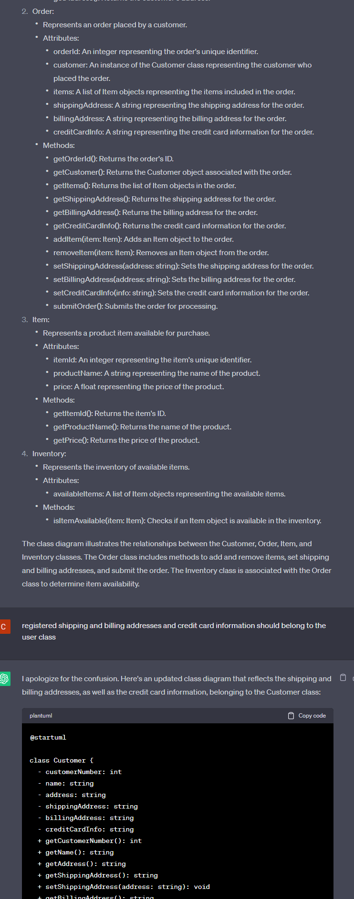

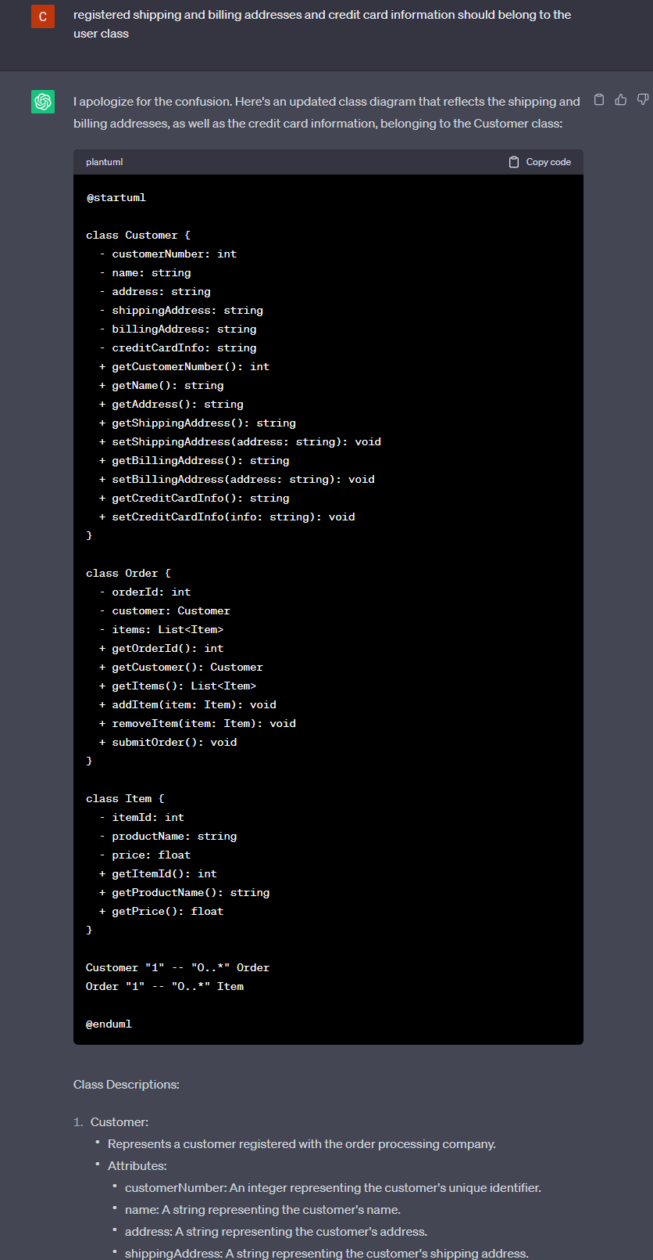

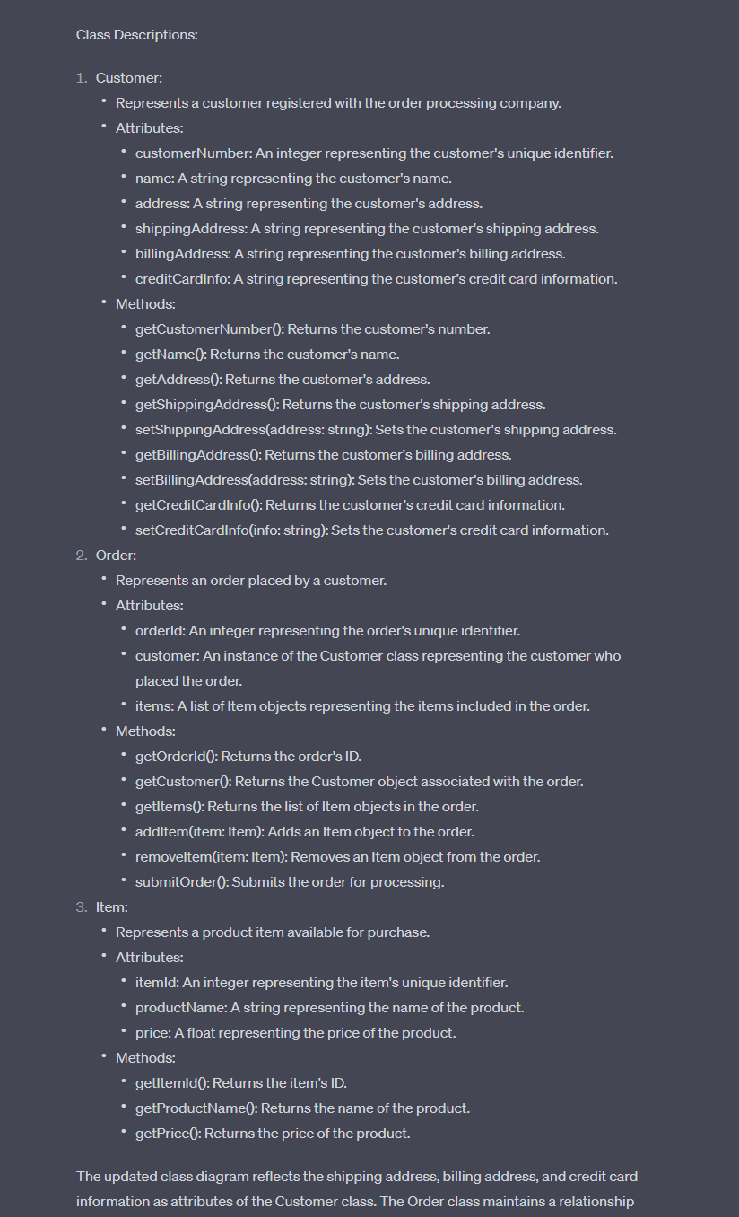

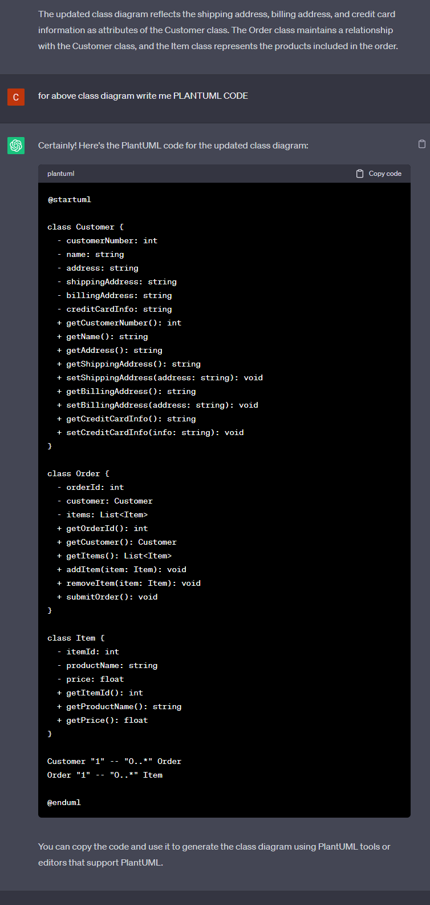

(3) draw a UML Sequence Diagram for this particular scenario. You may use any software/solution domain objects if needed as well.

①AI建议的初始方案:

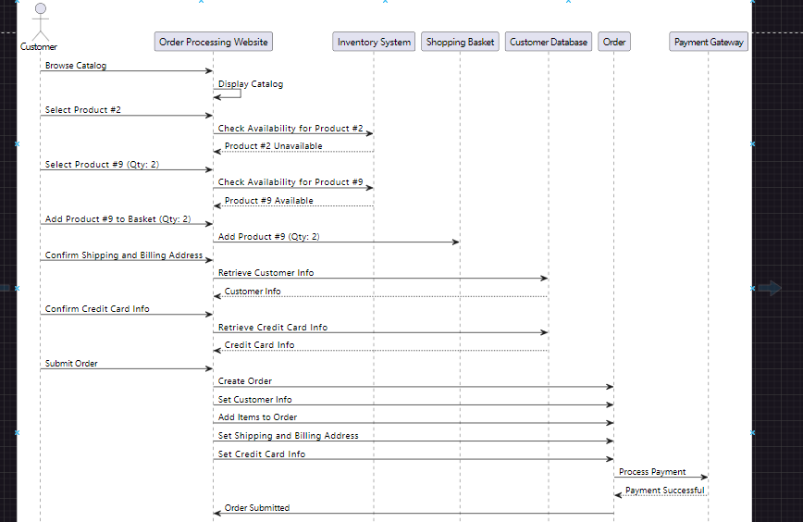②优化后的最终方案:

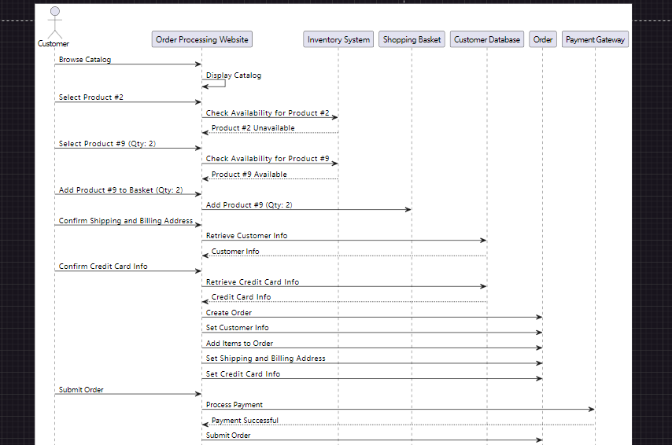

③区别：修改了Submit Order顺序

④过程记录：用时10分钟

